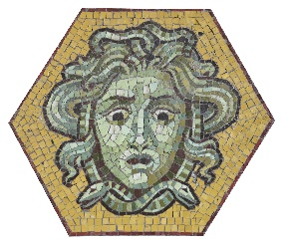 | PARTICIPATION INTEREST  6th SEE Mosaics Meeting  8-11 October 2024  Budapest, Hungary  MOSAICS FROM 1900's_  MODERN MATERIALS, NEW PROBLEMS IN FOCUS

Personal data
Name

Surname

Profession

Affiliation

Email address

Country

I wish to
attend with paper
* (20 min), but depends on the number of the presentations
attend with poster
* A0 format
attend without contribution

apply for grant
* only for applicants with contribution

Deadline for submitting participation interest by 25 March 2024
Please send the form to: seemosaics6budapest@gmail.com

